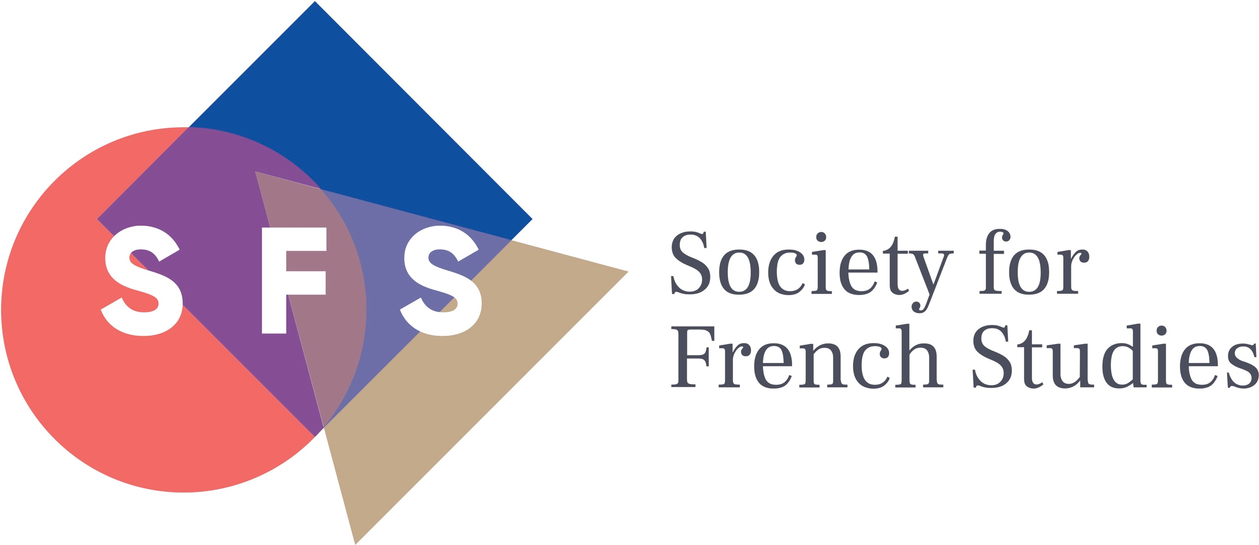

62nd Annual Conference
Queen’s University Belfast
28th–30th June 2021

SUPPLEMENTARY CALL FOR PAPERS

To supplement papers transferred from our 2020 conference, which was unavoidably cancelled due to the Covid-19 pandemic, we are pleased to invite additional proposals for papers (in English or French; duration: 20 minutes) for panel sessions on the following topics:

Defiance and Protest
Renewal
Linguistic Diversity
Separation and Isolation
Plague and Contagion
Community/Unity
Time

The suggested topics may be interpreted widely and are intended to encompass as broad an historical range as may be applicable. Please provide a short abstract (250-300 words), outlining the argument of the proposed paper and indicating the topic you have chosen. Abstracts should be framed with a view to addressing an audience made up of both specialists and non-specialists, and should include the proposer’s contact details (email & regular mail).

The Society encourages proposals for complete panels (of 3 or 4 speakers) on either the suggested topics, or from any area of French studies, and it is hoped that approximately half of the parallel sessions at the conference will emerge from complete-panel proposals. These should include the names, e-mail and postal addresses of all speakers, and those of the proposed session chair, who should not be one of the speakers. As well as a 250-300-word abstract for each speaker, proposals should contain a brief outline of the rationale and motivation of the proposed panel (no more than one printed page). One individual involved should be clearly designated as the proposer with overall responsibility for the proposed session. The Society is also happy to consider other formats than 3 to 4 traditional 20-minute papers for complete panels, which might include (but are not limited to): pre-circulated materials, performance or creative practices, project-based sessions, pedagogical workshops, non-academic partnerships.

Papers and panels are selected on the basis of peer review: you should know by mid November 2020 whether it has been possible to include your paper/panel. We especially invite applications from postgraduate students. NB. In order to encourage as wide a participation as possible, we have revoked the rule that no individual may present a paper at two successive annual conferences. Please note, however, that space in the 2021 programme is limited due to the exceptional circumstances of 2020.

Please send abstracts (by e-mail) by 30 September 2020 to the Conference Officer, Dr Victoria Turner at the following address: sfsconf2021@gmail.com. For further information on the conference, please see www.sfs.ac.uk.

