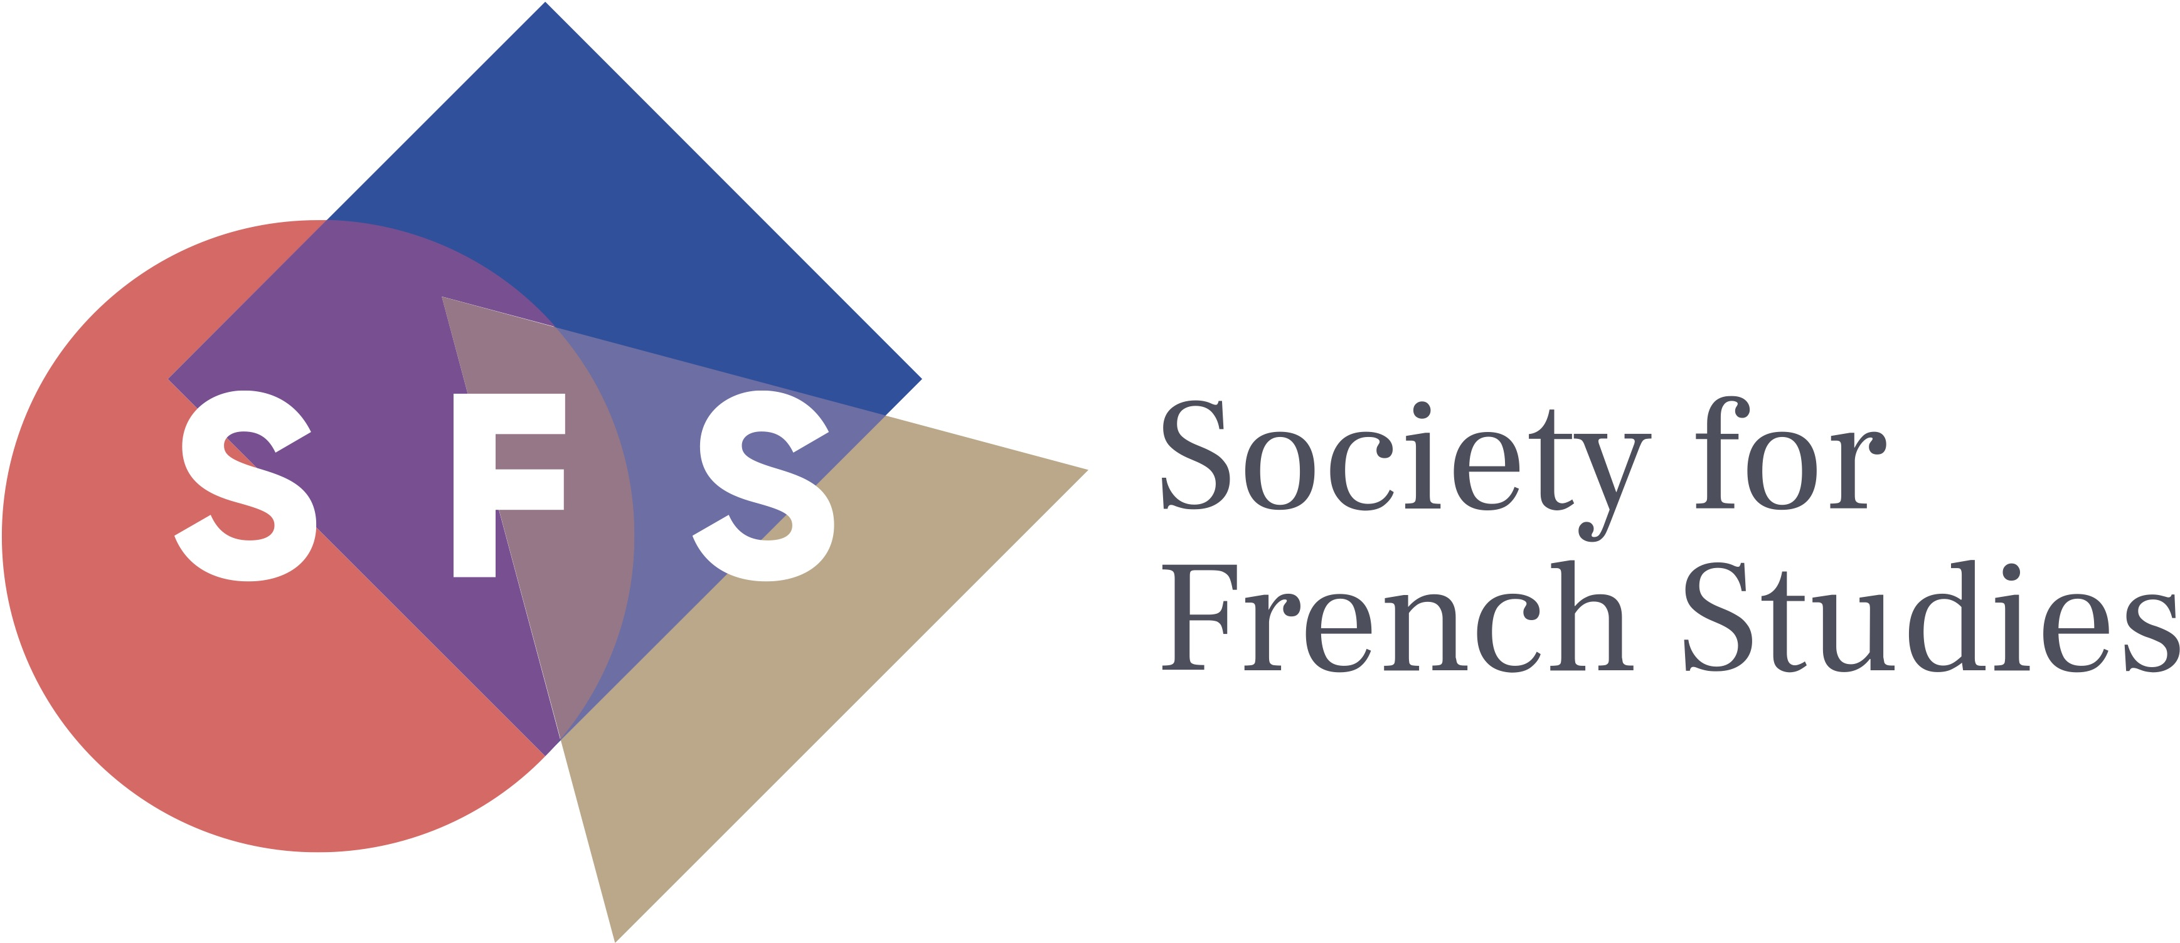

Postgraduate Travel Grant Application

The Society offers Postgraduate Travel Grants to help PG students meet the costs of travel to the conference from within the UK and Ireland. The amount of each grant is unlikely to exceed £150.

Please complete this form and send to the Conference Officer at the following address by Tuesday 15 May 2018:

Dr Nina Parish (Conference Officer)
Department of Politics, Languages and International Studies
University of Bath
Bath
BA2 7AY
UK
E-mail: n.parish@bath.ac.uk

Name:

Address:

Email address:

Institution:

Title of PhD:

Travel dates:

Breakdown of costs*:

Total:

Signature: Date:

* Travel should be the most economical means possible, making full use of advance purchase fares or any reductions available. The cost of taxis will not be reimbursed. Mileage costs for travel will not normally be paid.

We will inform you of the outcome of your application by Tuesday 29 May 2018. Successful applicants will be asked to send receipts for the expenses they incur to the Treasurer following the conference, at which point travel costs will be reimbursed. For enquiries, please email Postgraduate Officer Charlotte Thevenet, charlotte.thevenet.15@ucl.ac.uk

