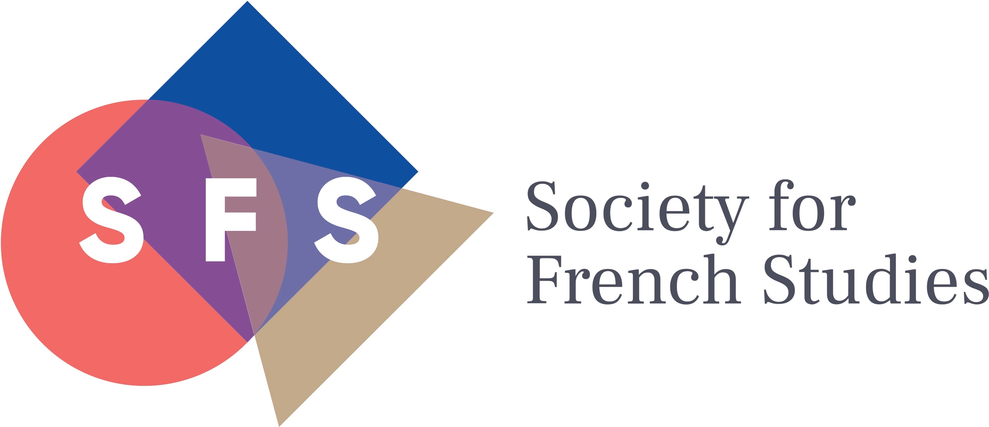

63rd Annual Conference
University of Belfast
27-29 June 2022

CALL FOR PAPERS

We are pleased to invite proposals for papers (in English or French; duration: 20 minutes) for panel sessions on the following topics:

60th Anniversary of Algerian Independence
Futures
Coasts/blue humanities
Stories and storytelling
Women intellectuals
Recovery
Centenary of Proust’s death
Performance
Conflict
Glottophilia/glottophobia
Freedom
Trade and/or exchange
Philosofictions (Philosophy and/as Fiction)

The suggested topics may be interpreted widely and are intended to encompass as broad an historical range as may be applicable. Please provide a short abstract (250-300 words), outlining the argument of the proposed paper and indicating the topic you have chosen. Abstracts should be framed with a view to addressing an audience made up of both specialists and non-specialists, and should include the proposer’s contact details (email & regular mail).

The Society encourages proposals for complete panels (of 3 or 4 speakers) on either the suggested topics, or from any area of French studies, and it is hoped that approximately half of the parallel sessions at the conference will emerge from complete-panel proposals. These should include the names, e-mail and postal addresses of all speakers, and those of the proposed session chair, who should not be one of the speakers. As well as a 250-300-word abstract for each speaker, proposals should contain a brief outline of the rationale and motivation of the proposed panel (no more than one printed page). One individual involved should be clearly designated as the proposer with overall responsibility for the proposed session. The Society is also keen to encourage other formats than 3 to 4 traditional 20-minute papers for complete panels, which might include (but are not limited to): pre-circulated materials, performance or creative practices, project-based sessions, pedagogical workshops, non-academic partnerships.

Papers and panels are selected on the basis of peer review: you should know by mid-December 2021 whether it has been possible to include your paper/panel. We especially invite applications from postgraduate students. NB. In order to encourage as wide a participation as possible, we have revoked the rule that no individual may present a paper at two successive annual conferences.

Please email abstracts by 15th November 2021 to the Conference Officer, Dr Richard Mason, at the following address: sfsbelfast2022@gmail.com. We are very keen for the conference to be an in-person event, however if you wish to discuss the possibility of a virtual panel, please indicate this when submitting your proposal. Travel bursaries are available to support postgraduate participation. For further information on the conference, please see www.sfs.ac.uk

